. Introduction
The Rockville Cafe website is centered around the historic Rockville Bridge. The website will provide a brief history on a separate page and allow users to view the menu, order the meal online, see where the cafe is located, and view the daily specials
Features included:
- about us page
- food menu
- weekly specials
- order online
- contact us information

2. User Interface Design and Prototype
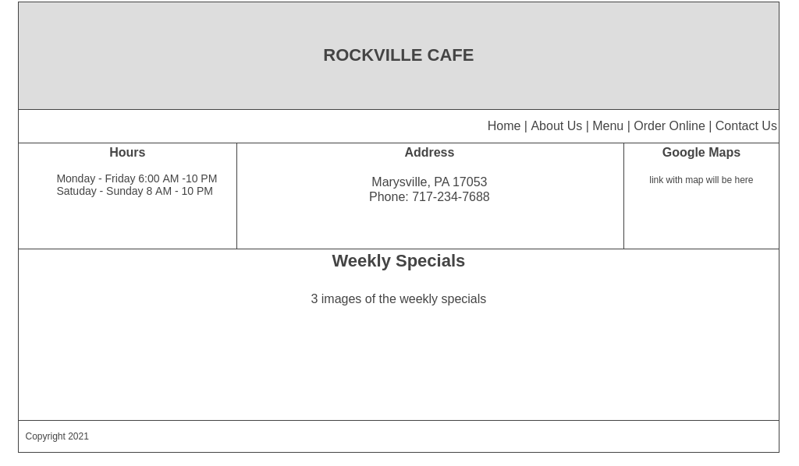
I have a lot of work to do to find the color scheme. The layout reasoning is to keep the web page simple offering the most relevant information to ordering the food first and then showing the weekly specials. I intend to put an image of the Rockville Bridge in the title block and images of the specials in the middle section aligned horizontally.

3. Navigation Structure
- Simple navigation from the home page to the four areas of the website

4. References
- No references

